**Description of the Project:**

Group Travel payment settlement app is managing the transactions of users for the group who are paying the expense for the trip. It is also maintaining the settlements after completion of the trip.

**Design:**

**Frameworks and technologies:**

Spring boot, Angular 6, MongoDB, Consul, Java, OAuth2.

Architecture Diagram:

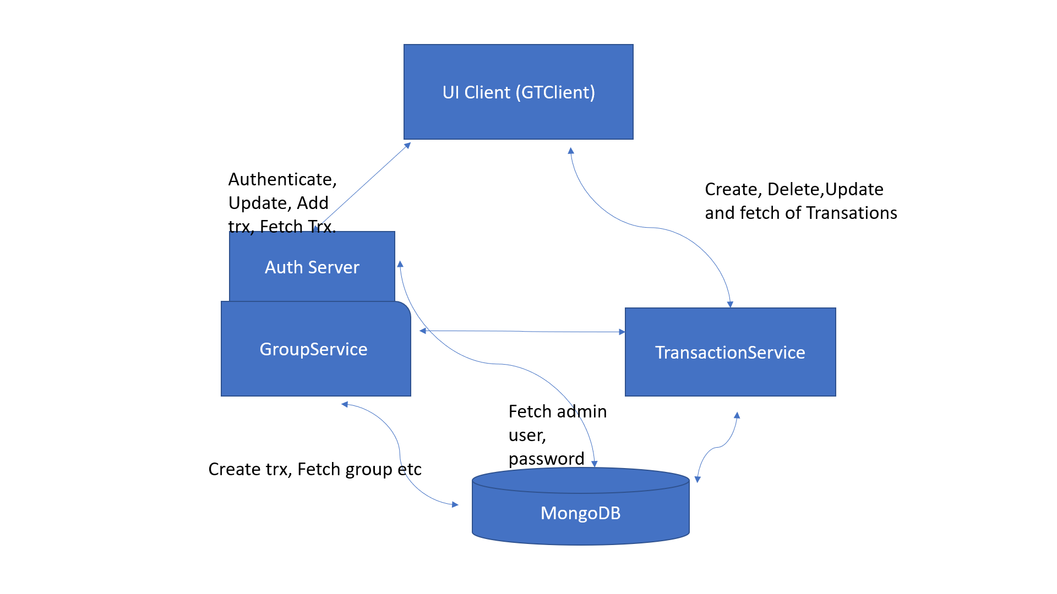

**Client: gtclient**

I have designed the client app with angular.

**Backend Servers: groups and transaction.**

I have developed two main micro services to serve the group travel system. I used MongoDB has backend database.

**Group**: This micro service will manage the groups creation, edit, deletion and update operations.

Create:

For a **group table** contains following fields

String groupName;

String groupId;

String groupDescription;

**double** expectedExpence;

**double** actualExpence;

Set userList;

String groupAdmin;

Set<Transaction> transactions;

**Transaction**: This micro service will manage the transaction creation, edit, delete and update operations.

For Transaction table contains following fields.

String transId;

String groupId;

String userId;

Date date;

String cause;

**double** expence;

**Deployment:**

**Install MongoDB:**

1. Install mongoDB in your system with default port. I used the default port and localhost as hostname in application.properties of both microservices

**Install Consul:**

1. Install consul for resource discovery and start consul server to register the microservices.
2. To Download consul software:

<https://www.consul.io/downloads.html>

1. Download the consul software and go to the home folder of consul and run bellow command to start the consul.

**COMMAND** : consul agent -server -bootstrap -data-dir temp1

**Run Transaction microservice:**

1. Download transaction project from <https://github.com/vcsrayudu/zycus>
2. Open transaction project in SpringToolSuite4.exe
3. Run as Spring Boot App.

**Run groups microservice:**

1. Download groups project from <https://github.com/vcsrayudu/zycus>
2. Open groups project in SpringToolSuite4.exe
3. Run as Spring Boot App.

**Run gtclient:** This is a client application to access the Group Travel Payment System

1. Download gtclient project from <https://github.com/vcsrayudu/zycus>
2. Follow the steps to setup for angular in <https://www.tutorialspoint.com/angular4/angular4_project_setup.htm>
3. Go to the extracted folder and run ng serve.
4. Open ULR <http://localhost:4200>

**Login:**

First create a group by clicking on Register new group link.

Registration page you can enter all group details like name, login name, description, participant users etc.

Once registration done then you can login with the group user and password.

Then you can create Transactions for users in the group. Once transaction are created the page is automatically updating all the fields like actual expense, User specific expenses etc.

This UI app provide many options to create multiple transactions, Delete the transactions, Create Settlement transaction, Edit the group etc.

For more details please check the screenshots at <https://github.com/vcsrayudu/zycus>

**Improvements:**

1. Better UI design.
2. Better navigation plan like trip planning, visiting locations, descriptions of each location.
3. Login for each user specific, Membership registration etc.
4. Payment gateway in place of settlement.